Site Selection:
9 organic sample sites were chosen from farm parcels of Stone House Grain to represent a range of managements and soil texture diversity (Table 1). Site EF02 represents a nearby conventional system and was used as a baseline for carbon content comparison. For fields with diverse topography, an area with a flatter slope and average elevation was selection for study.
Table 1: Sample Site Coordinates

Soil Sampling Design:
Drawing on the work of Peter Donovan (Sources), Hudson Carbon developed a triangular grid sampling pattern which creates a set of 3 replicate sampling hexagons, positioned around a fixed centroid point. Each hexagon (North-“N”, East-“E”, West-“W”) is comprised of eight sampling points per year, representing eight months (April-November) of the growing season. Biomass sampling is collected at each point throughout the season. Soil cores are sampled at the end of the growing season and the beginning of the season for certain years & sample sites (Table 2). A Leica Zeno 20 was used to pin the centroid point & locate future sampling points (Sources).

Table 2: Sample Site Coring Seasons
 | Fall 2016 | Spring 2017 | Fall 2017 | Spring 2018 | Fall 2018 | Spring 2019 | Fall 2019 | Spring 2020
CS 01 | x | x | x | x | x |  | x
CS 02 | x | x | x |  | x |  | x
CS 03 | x | x | x
CS 04 | x | x | x | x | x |  | x
CS 05 | x | x | x |  | x |  | x
CS 06 | x | x | x |  | x |  | x
CS 07 | x | x | x |  | x |  | x
CS 08 | x | x | x | x | x |  | x
CS 12 | x | x | x | x | x |  | x
EF 02 |  |  |  | x | x | x | x | x

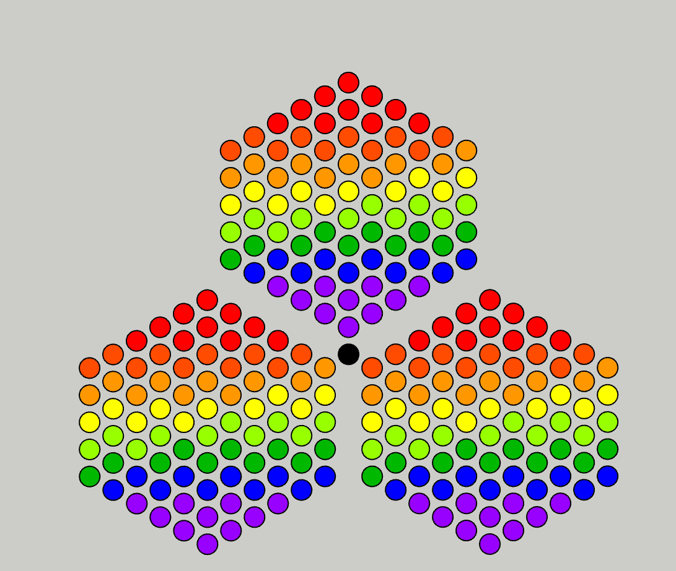
Replicate 3 “W”
Replicate 2 “E”
Replicate 1 “N”

Figure 1: 10 Year Sampling Grid
A 10-year sampling grid was created and laid around the centroid point of each Hudson Carbon research site. Each color represents a different month (April points are red, through November in purple). This protocol allows us to measure the change in carbon stocks in biomass and soil over time with minimal spatial variability.

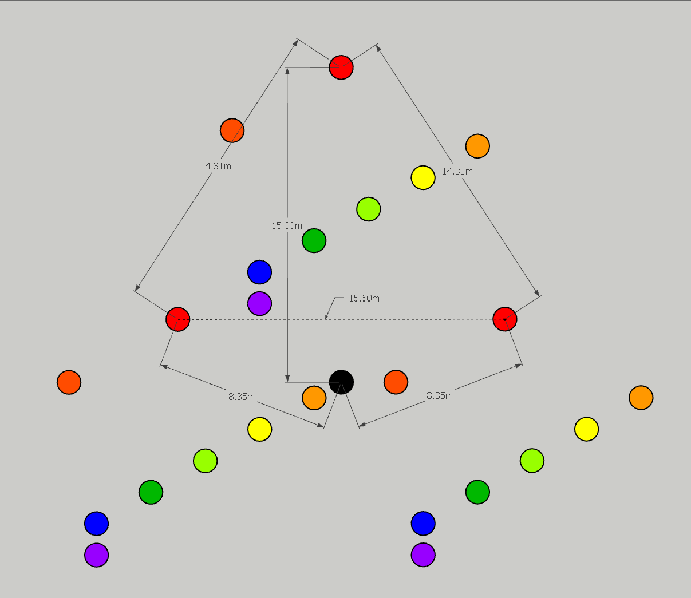
W
E
N
Figure 2: 1 Year Sampling Grid
Figure 2 depicts all sampling points for one growing season. The N, E & W labeled points indicate replicates. The dimensions between replicates are 14.3, 14.3, and 15.6m sides. These dimensions are not representative of the sampling grid layout for EF02-baseline site (Figure 4).

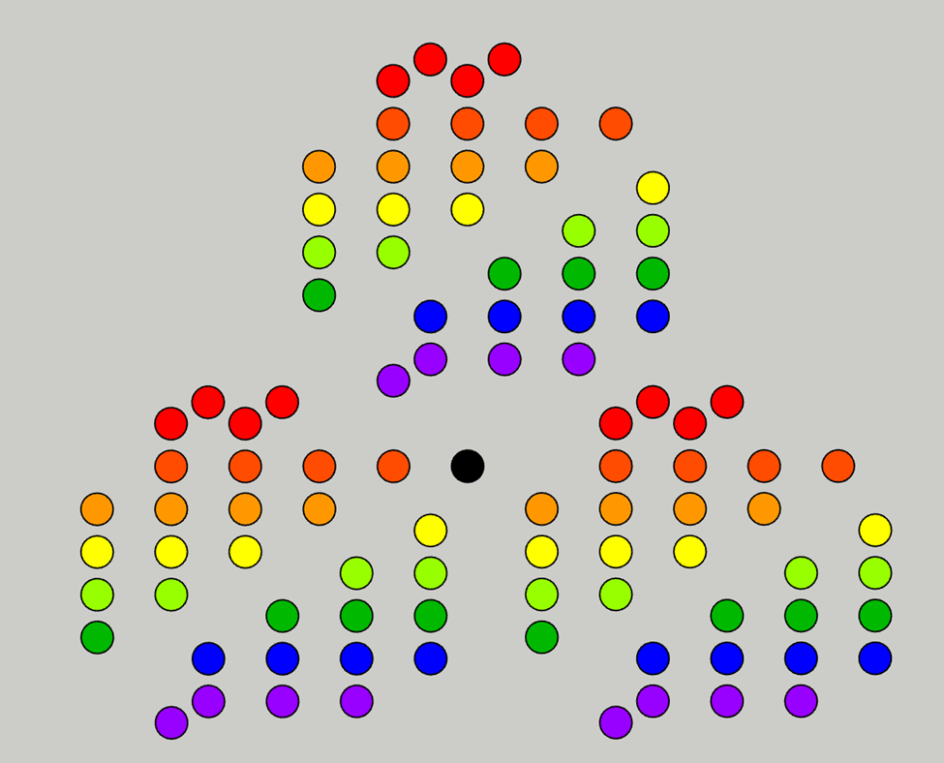
9m
6.5m
5.5m
6.5m
2.5m
2017

2018
2016
2019
2018
2017
Figure 3: Fall 2016-Spring 2019 Sampling Grid
Figure 3 represents the sampling grid from 2016-2020. Coring locations are denoted with (Fall) and (Spring). Dimensions between the coring points are noted on the graph. Within one replicate hexagon, the area between Fall cores from 2016-2019 is 6.7 m², and 58.5 m² between all cores (Spring & Fall). Multiplying this by 3 replicates, results in a total ground coverage area of 20.1 m² for Fall cores, and 175.5 m² for all cores.
No Spring cores were taken in 2019 or 2020 for sample sites, excluding the EF02-baseline site. These dimensions are not relevant for EF02.


140m
140m
140m
W
E
N
Figure 4: EF02 1 Year Sampling Grid*
Figure 4 represents the 1-year layout and dimensions between replicates for the EF02-baseline site sampling grid. The 140m equilateral sampling grid for EF02 is much larger than the grid for all other sample sites.
*Not drawn to scale.
Soil Core Extraction Procedure:
- Using the Giddings hydraulic soil coring rig (sources), pull one 1m core sample from each flagged sampling point.
- Remove plastic sleeve containing soil core sample and place caps on either end.
- Mark cap with proper sample ID
  - Sample ID format: “Julian Date. Sample Site. Sample Replicate (N,E,W)”
- Bring core samples to lab for processing.
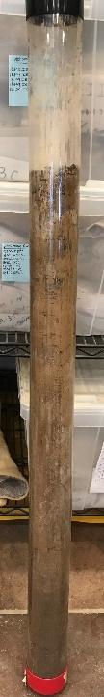
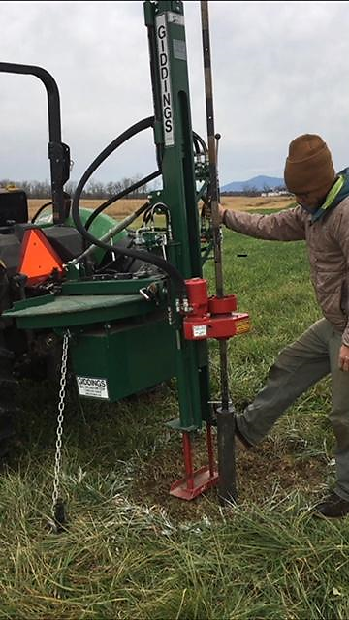
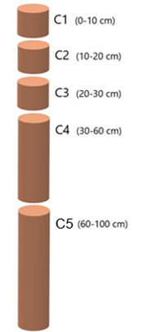

Figure 7: Soil Core Horizons
Figure 6: Soil core in plastic sleeve
Figure 5: Soil core extraction with Giddings unit

Lab Analysis Procedures:
Receiving Samples
- The collection of samples gathered from one sampling event are received, documented in the lab notebook, and placed within the horizon slicing template.
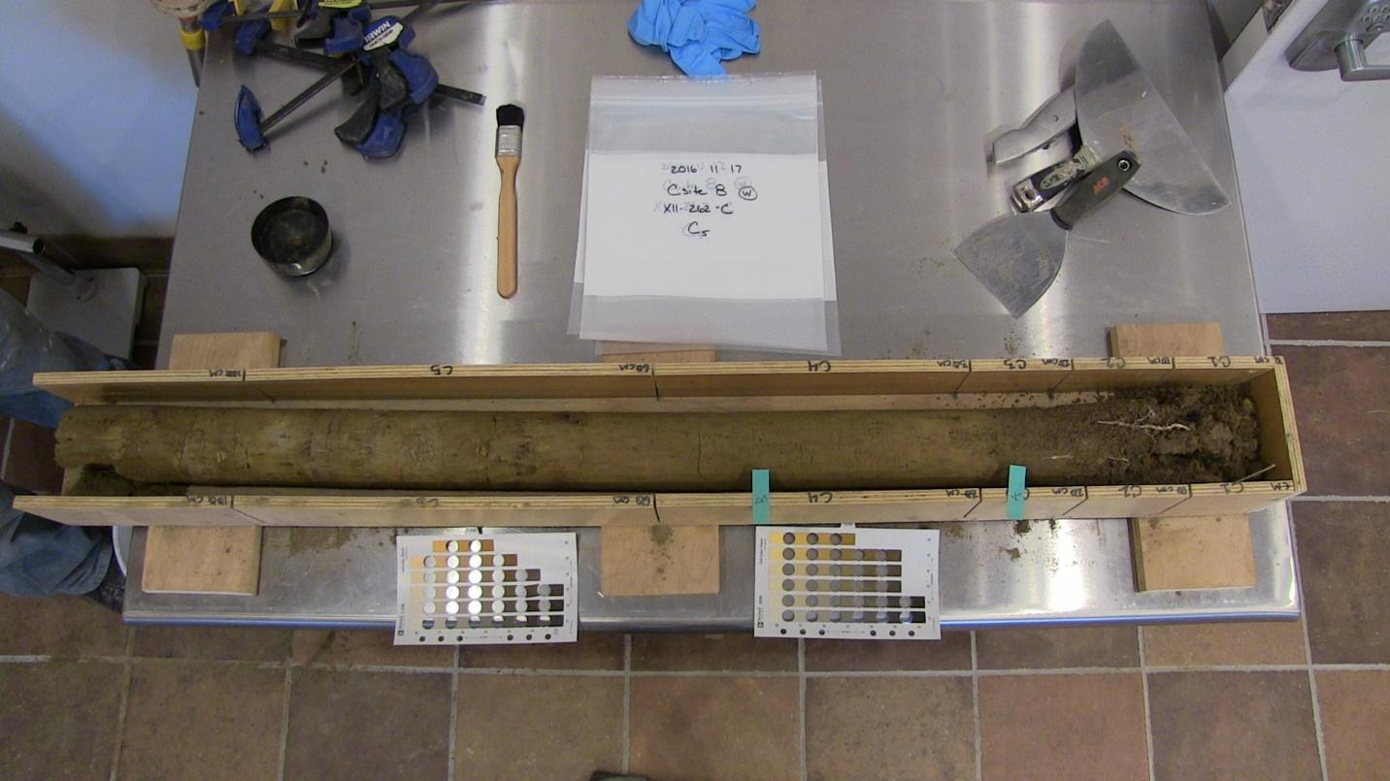
Figure 8: Breaking down a soil core
Splitting Soil Core into Horizons
- Soil cores are carefully removed from the plastic sleeve into the horizon slicing template.
- The A and B horizons are marked correspondingly on the slicing template and the core is photographed with a visible label of the Sample ID and Munsell Soil-Color Charts (Figure 8).
- Starting with the deepest horizon (C5), and progressively working up to surface (C1), the core is sub-divided by cutting at designated depth horizons, C1 = 0-10cm, C2 = 10-20cm, C3 = 20-30cm, C4 = 30-60cm, C5 = 60-100cm (Figure 7). All soil for each horizon is carefully collected and homogenized in a pre-tared metal bowl.

Bulk Density Measurements
- Following this homogenization, the soil in each horizon is weighed and recorded as the wet weight(CW) of the horizon. A 3-5 gram(g) subsample is collected and oven dried to calculate soil horizon moisture (Equation 1). These measurements are conducted for each of the three replicate cores. The three replicate soil moisture and wet weight values are averaged and input into the following formulas to determine bulk density(BD) and kg soil/ha (Equations 2, 3, 3b, & 4).

Equation 1.
$$MC=\frac{W}{D}÷D×100\%$$

Where: MC=%moisture content W=3-5g wet weight D=3-5g dry weight
Equation 2.
$$CD=CW-MC×CW$$

Where: CD = calculated core dry weight CW = core wet weight
Equation 3.
$$V=π× r^{2}×h$$

Where: V=core volume h=core height: differs by horizon C1-C3=10cm, C4=30cm, C5=40cm
Equation 3b.
$$BD (g/{cm}^{3})=CD÷V$$

Where BD = Bulk Density
Equation 4.
$$Soil \left(\frac{kg}{ha}\right)= BD \left(\frac{g}{{cm}^{3}}\right)×h×100000$$

Where Soil (kg/ha) = Soil kg per hectare h = core height 100,000 = unit conversion

Sending samples to outside labs
- The remaining soil sample is placed in an appropriately labeled zip lock bag (“Julian Date. Sample Site. N,E,W”) and stored in the refrigerator, until all soil cores are processed to this point.
- The N, E, & W replicates of each soil horizon are removed from the refrigerator and homogenized together. From this homogenization, the appropriate amounts of soil are removed and sent to the following laboratories for further analysis; Logan Labs-Lakeview OH, Waypoint Analytical-Memphis TN, Woods End-Mt. Vernon ME, Boston University Stable Isotope Lab-Boston MA, Marine Biological Stable Isotope Lab-Woods Hole MA.
- Sample bags are placed into corresponding labelled shipping boxes and packed to minimize shifting. A completed sample submittal form is placed in the box, shipping labels are adhered, and the box is sealed to be shipped out. Samples waiting to be shipped will be stored in the refrigerator until they are shipped.
- The remaining sample, not sent to outside labs, is spread out on a sheet pan and placed on a drying rack to air dry. Samples are weighed daily until 0% moisture loss is observed. Samples are then put in labelled bags and stored at room temperature.

Outside Lab Protocols:
Loss on Ignition
Logan Labs, Waypoint Analytical, and Woods End each run Loss on Ignition (LOI) tests for submitted samples. All labs immediately air-dry soil samples when they are received. Each lab has slightly different protocols for the LOI methodology (Table 3).

Table 3: LOI Methodology Discrepancies
*Hudson Carbon runs four LOI replicates for each sample. Hudson Carbon LOI data is not included in this analysis, as not all samples have been analyzed at this point.
Dry Combustion
The Boston University and Marine Biological Stable Isotope Laboratories each run Dumas Dry combustion testing for %C content. Both labs air dry and pulverize soil upon receiving samples.
Boston University uses an Elementar Cube elemental analyzer. The Marine Biological Lab uses a Thermo Flash elemental analyzer.

Linear Regression Method:
Soil C kg/ha values were produced for each round of coring (Equation 5) using reported values & calculated %OM to %C conversions (see “Verification Dataset Final-1” excel). Each round of coring from Fall 2016-Spring 2020 was assigned a time(t) value (Table 4).
Equation 5.
$$Soil C\left(\frac{kg}{ha}\right)=\%C× Soil \left(\frac{kg}{ha}\right)$$

Where: Soil C (kg/ha) = Soil Carbon kg/ha

Table 4: Coring Season Time(t) Values
Coring Season | Year (t)
Fall 2016 | 0.5
Spring 2017 | 1
Fall 2017 | 1.5
Spring 2018 | 2
Fall 2018 | 2.5
Spring 2019 | 3
Fall 2019 | 3.5
Spring 2020 | 4

In cases where data did not exist (Spring of certain sample sites), no t value was assigned. A linear regression was made between soil C kg/ha and t for each sample site producing soil C flux in kg/ha/yr. Slope and intercept were converted to tons C/ac/yr (Equations 7 & 8). Carbon Dioxide (CO₂) equivalents were calculated for each soil C flux (Equation 9). The standard error of each linear regression was determined using the excel “Linest()” function (Sources) (see “Verification Dataset Final-1” excel).

Equation 7.
$$\frac{\frac{tonnes C}{ha}}{yr}=Soil C\left(\frac{kg}{ha}\right)×.001$$

Where: .001=conversion factor from kg to tonnes
Equation 8.
$$\frac{Tons\frac{C}{ac}}{yr}= \frac{\frac{tonnes C}{ha}}{yr}×1.10231 \left(\frac{Tons}{tonne}\right)×0.404686\left(\frac{ha}{ac}\right)$$

Equation 9.
$${CO}_{2} Equiv. =Soil C Flux×3.67$$

Where: CO₂ Equiv. = CO₂ equivalents for Soil C Flux 3.67=molecular weight conversion factor

Sources
Donovan, P. (2010). Measuring soil carbon change. A flexible, practical, local method.
http://escueladeregeneracion.com/wp-content/uploads/2019/07/MeasuringSoilCarbonChange.pdf

Morrison, F. A. (2014). Obtaining uncertainty measures on slope and intercept of a least squares fit with Excel’s LINEST. Houghton, MI: Department of Chemical Engineering, Michigan Technological University. Retrieved August, 6, 2015. http://facstaff.cbu.edu/~jvarrian/452/UncertaintySlopeInterceptOfLeastSquaresFit.pdf

Boston University Isotope lab https://www.bu.edu/sil/

Logan Labs-https://loganlabs.com/

MBL stable isotope lab https://www.mbl.edu/ecosystems/silab/

Waypoint Analytical-https://www.waypointanalytical.com/

Woods End-https://woodsend.com/

Giddings Coring Tractor Implement-
https://www.soilsample.com/all-tractor-machines

Leica https://leica-geosystems.com/products/gis-collectors/gis-handhelds-tablets/leica-zeno-20

